AN INTEGRATED AGRICULTURAL LAND-USE PLANNING SYSTEM FOR THE VIETNAMESE MEKONG DELTA. A CASE STUDY IN SOC TRANG PROVINCE

Quang Chi Truong 1, Thao Hong Nguyen 2*, Vu Thanh Pham 1 and Trung Hieu Nguyen 1

*1 College of Environment and Natural Resources, Can Tho University, Can Tho 94100, Vietnam*

*2 Faculty of Agriculture, Can Tho Technical Economic College, Can Tho 94100, Vietnam*

# Abstract

Assessments of socio-economic- environment factors to find the good plans is an important step in carrying the agricultural land-use plans. It is thus need an integrated tool to support this work. This research aims to build an integrated tool named ISALUP (Integrated System for supporting Agricultural Land-use Planning) for supporting agricultural land-use planning. This integrated system composed a new application module for optimizing land-use areas and a land-use allocation module that is taking into account socio-economic and environmental factors. The integrated system ISALUP has been applied in 3 districts (Long Phu, My Xuyen and Tran De) of Soc Trang province, Vietnam. In the context of climate change, optimal solutions are adopted, such as multi-objective solution (profit, labor, environment benefit and risk reducing) versus a maximizing a single objective (profit, land appropriateness) for land usage through 2030. In which the profit-maximizing plan provided the highest profit value, however the multi-objective optimization was the considered option to implement land-use plan thank to the balance between good profit and reducing risk of economic and environment. The land allocation was carried out that was taking into account factors of household economic, the influence of adjacent production types, local transportation and canal systems for allocating optimized land-use area in the system. This would show that the integrated system could be used as a decision supporting tool for optimization objectives the land-use planning process that can help planners to improve the quality of agricultural land-use plans.

Keywords: land-use planning, land-use allocation; land-use optimization; land-use allocation; ISALUP

1. Introduction

The Mekong Delta is Vietnam's largest food producing region, accounting for 55.7% of Vietnam's rice production [1], yet people's incomes remain poor and vulnerable to climate change and sea level rise [2,3].

Climate change and sea level rise are expected to have a significant influence on agricultural land usage [3,4]. Many writers evaluate many land-use types as risk-reducing uses because of harsh weather or climate change, such as the rice-shrimp type for coastal brackish water [5]. The rice-vegetables type for freshwater ecoregions examined for climate change adaptation in the setting of freshwater scarcity due to saline intrusion [6,7]. However, the area of rice-shrimp is declining because farmers pursue profit without regard for the environment [8], and the usage of shrimp and rice-vegetables have trouble identifying the right area and financial capabilities for implementation [9]. This presents managers with the challenge of developing agricultural land use options that provide high profitability while minimizing costs, hazards, and environmental implications.

For agricultural land-use planning, the plans have been base on the FAO's guiding procedures consists of 7 steps [10]. In which the important step of alternative assessment of socio-economic factors for land-use optimization using linear programing [11] but it is still lag of tool to support planners in developing regions [12].

Land suitability evaluation methods have been utilized in studies on the selection of suitable agricultural land-use types to determine suitable regions for land units [13]. Furthermore, the linear programming method has been used in conjunction with GIS to optimize land use with the goal of maximizing land use area with technological, capital, and ecological restrictions [14].

Multi-objective optimization studies such as cost minimization combined with maximum area of usage [15] are used in a multi-objective environment. Or a combination of objective land use choices to maximize profitability while reducing carbon emissions and increasing environmental benefits [16]. To compute the optimal area of dominating uses across the entire research region, some studies employed linear maximization [17]or neuron networks [18].

For related studies in the Mekong Delta, recent optimality studies have used the optimal approach for each land mapping unit [13]. The suitable optimal objectives such as maximizing profits, labor, cost, capital efficiency and land adaptation [19,20]. The advantage of these methods is to propose the optimized area for agricultural land-use types (LUTs) based on socio-economic and environmental constraints for each land mapping unit. But these studies lack a tool for land-use allocation for users when arranging land use types on the map and the mathematical models are not easy to use for managers.

Regarding land-use allocation, many methods for land allocation have been use. Most of which are based on the suitability of each land [19,20] where the precise spatial distribution of LUTs were not able displayed. Another approach employs the Cellular Automata (CA) method of automatic cell analysis [21]. Many studies use the CLUE-S model [22] to predict land layout, with the outcomes of optimizing the area of land use categories as the input constraint of CLUE-S [23,17,18]. Some studies employed a distinct model to solve the problem of spatial layout of urban land use while taking infrastructure into account [24].

These methods have helped planners in their decision-making. However, these spatial arrangement methods need to take into account specific impact factors on land-use such as infrastructure for agriculture as well as the risk on implementation, capability investment of land-use types in different conditions. Other factors to consider when allocating land in developing regions include road and drainage system development, the proportion of poor households in the area, and the influence of urban areas. Furthermore, when implementing land allocation options for agricultural production, the surrounding area's use patterns should be considered.

Given the current situation, it is necessary to conduct a study to propose the optimal use of land for agricultural production in order to meet the desires of local farmers to increase their income and to support the work of agricultural land planning by local government, as well as to construct a system of land-use arrangement for agricultural production that takes into account the socio-economic factors in the local area that affect the spatial arrangement of agricultural land-use types. The objective of this study is to create an integrated system that provides tools to assist planners in maximizing agricultural land-use solutions and spatial distribution of these plans. The new model takes not only socio-economic and environmental factors but also reducing risk of implementation and effect of environment.

1. Materials and Methods
   1. Study area

Soc Trang province is located in the Mekong Delta at the southern mouth of the Hau River, about 60 kilometers from Can Tho. It shares borders with Hau Giang, Tra Vinh, Bac Lieu, and the East Sea. Soc Trang province has 11 administrative units in 2023, including Soc Trang city, Vinh Chau town, Nga Nam town, and 8 districts (Ke Sach, My Tu, Cu Lao Dung, Long Phu, My Xuyen, Thanh Tri, Chau Thanh and Tran De).

The study area was chosen based on contiguous districts with ecological characteristics of fresh, brackish, and saline water. This helps with the mapping of specific land uses for these ecoregions. The study area consists of three districts in Soc Trang province, based on the criteria chosen: My Xuyen, Long Phu, and Tran De (Figure 1). Long Phu, in particular, is in a freshwater area but is vulnerable to saline intrusion during extreme weather events (such as the 2016 drought and saline intrusion); My Xuyen is in a brackish water region; and Tran De is divided into two areas: the saline area outside the dike systems at the river's mouth and the freshwater area inside the dike systems.

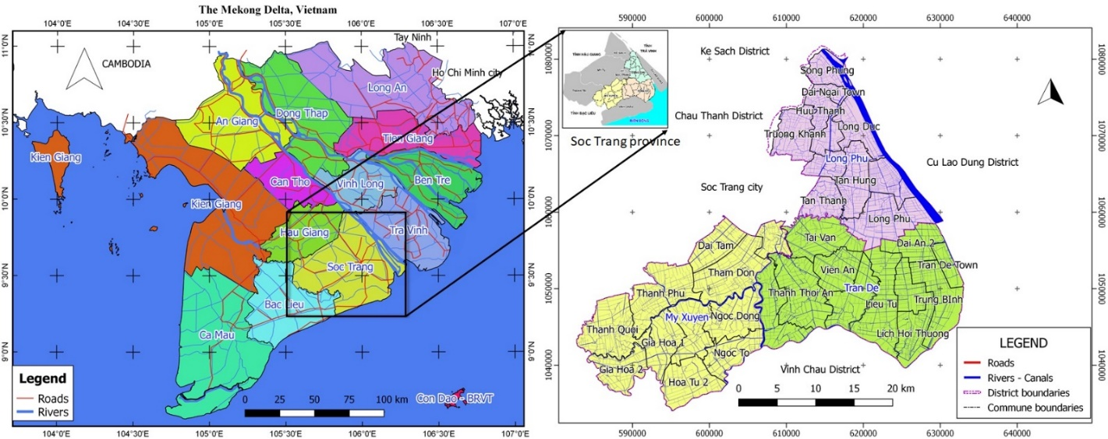

Figure 1. The study area in Soc Trang province, Vietnam.

The statistics from 2010 to 2018 of all three districts are shown below to analyze changes in the area of rice cultivation over time as a basis for predicting the area for specialized cultivation, fruit trees, and aquaculture. as illustrated in Figure 2. Specifically, the districts' cultivated area only focuses on producing two crops, the summer-autumn crop spanning a large area of cultivation. The data shows the total area of rice cultivated in the year.

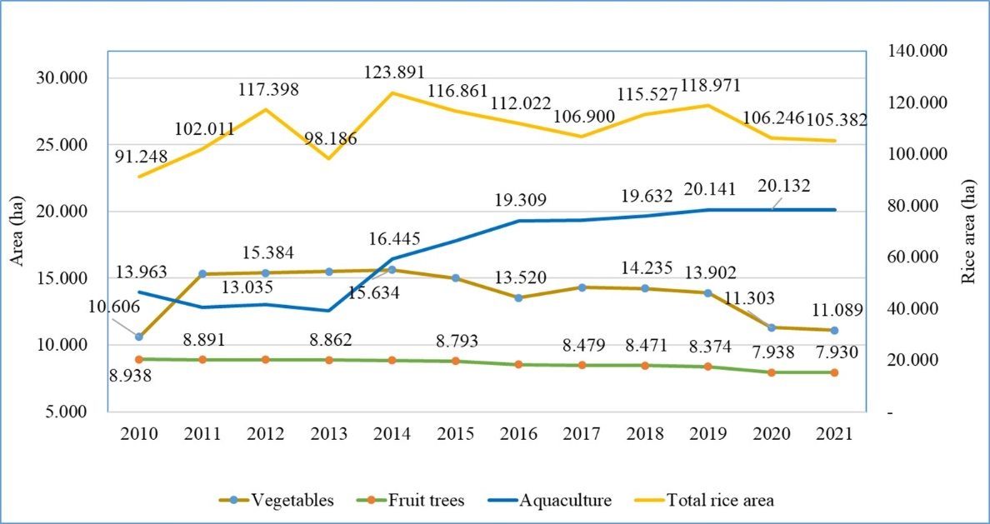

Figure 2. Cultivated agricultural land-use area of three districts from 2010 to 2021.

Figure 2 depicts the cultivated area of vegetables, fruit trees, and aquaculture in the districts of Long Phu, Tran De, and My Xuyen from 2010 to 2021. In general, the area of vegetables and crops has fluctuated, but there has been a consistent increase in recent years. In contrast, the area of Fruit trees varies the least, ranging from 8,546 ha to 8,938 ha. From 2010 to 2021, the aquaculture sector in particular grew steadily.

Data collection

Based on research of Lambin and Geist [25], the previous studies and Vietnamese works, the factors influencing land use type selection were chosen from similar studies in the Mekong Delta, Vietnam as in Table 1. Economic variables such as profit and market demand are the elements influencing the area of relevant land use types. The component of investment capital and household capital indicate whether or not the household has the ability to arrange various types of land-use. Many studies have examined how social factors like labor, educational level, and infrastructure issues influence land use. To examine the possibilities of choosing land use, natural conditions of soil, water, environmental benefit and risk of land-use are surveyed.

Table 1. Socio-economic factors related to land-use

|  |  |  |
| --- | --- | --- |
| Factor group | Factors | Source |
| Economic | Profit | Santiphop et al. [26]; Liu and Xia [27]; Le et al. [28]; Pham et al. [29] |
| Capital, cost | Le et al. [28]; Sofi et al [30] |
| Household capital | Bui et al. [31]; |
| Market demands | Santiphop et al. [26]; Liu and Xia [27] |
| Social | Labor | Pham et al. [29]; Sofi et al [30] |
| Educational level | Bui et al. [31]; |
| Neigborhood effect | Le et al. [32]; |
| Infrastructure (road, canels) | Le et al. [28]; Liu and Xia [27] |
| Environment | Risk of land-use | Nghi and Hien [33]; Pham et al. [29] |
| Natural factors: soil, water | Most related research |

The field survey was conducted in four communes with 150 typical farmers. Individual interviews were conducted with advanced local farmers who had at least ten years of farming experience in the study area. The questionnaire is designed to collect data on household characteristics related to profitability, total cost, profits, labor demand, environmental benefits, and risk of LUTs for each land-use type (LUT). People evaluated that their LUT had a positive impact on improving the quality of the environment, and the risks of LUT were divided into four levels (high, medium, low, and no risk), corresponding to the percentage of farmers self-assessing the level of risk in agriculture production. The following data was encoded and descriptively statistically analyzed using Microsoft Excel software as the ISALUP's input data source.

Besides, the maps of soil type, depth of alum formation, water salinity and duration of water salinity in 2015 were obtained from the Department of Agriculture and Rural Development of Soc Trang province. The study area's land use map in 2015, as well as the saline intrusion maps in 2010 and 2015, were analyzed using data from the Department of Natural Resources and Environment.

* 1. Proposition the ISALUP system

The ISALUP (Integrated system of agricultural land use planning) system is made up of three blocks, as shown in Figure 3. The first section specifies the input data source, which includes economic, social, and environmental data; the second block contains the module for optimizing agricultural land area (Land Optimization Module); and the third block contains the module for spatial allocation for land use types (Land Allocation Module).

The model's input data sources include socioeconomic and spatial data. In which socio-economic data contains information gathered during the economic research of land use types, such as costs, profits, working days, and people's perceptions of the environmental advantages and risks of land use. Base map layers (such as soil, acid sulfate, salinity, and fresh water supply layers) are included in spatial data. To build a land unit map, these maps are overplayed using the Union method. These land units are naturally categorized for local land use types according to FAO [13]. Other types of spatial data include infrastructure map layers for analyzing appropriate locations of use types (roads, canals).

The Land Area Optimization module (Figure 3) stated in block 2 employs the linear programing method to determine the area of use types in each land unit with the best objective function for profit maximization or multi-objective optimization. This module was created with the Visual Basic.NET programming language and the LPSolve API function [34]. Section 2.2 defines the objective function and constraint equations in detail. This module produces a CSV file that describes the area of each usage for each land unit.

The Land Allocation module is presented in block 3 of Figure 3, this module is built according to the grid layout method on GAMA platform software [35]. In which, the output area of the Optimizer module is used as the land layout requirement condition of this module. The procedure for allocating the required area for each land unit is summarized as follows: First, a temporary land use type is assigned to the cells within the same land unit. For a land unit allocated for only one land use type, the land arrangement is completed. For land units allocated for multiple uses, the temporarily allocated step assign all of its cells with a non-priority land use type as a based map (it means the allocated area greater than the requirement). These cells are noted by unallocated label. Next, each unallocated cell is calculated the appropriate indices for the land use types including LUT density, distance to canal (IC), distance to traffic (ID) and the ability to arrange each LUT (Icap_LUT). Continually, the iterative process for each land-use type to sort cells which Icap_LUT in descending order and set the land-use types for these cells. The output of the integrated system is a map of land use options arranged according to the required area and with the appropriate spatial location according to the requirements of the type of use.

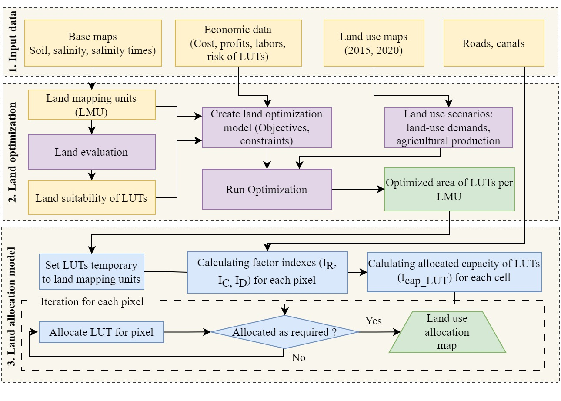

Figure 3. Method diagram of ISALUP.

* 1. Method for agricultural land-use optimization

The Land Optimization module was created on the Windows operating system using the programming language Visual Basic.Net. The main mathematical model of the module is showed in the following sessions.

2.2.1. Optimization objectives

The function of maximum land suitability (Equation 1), profit maximization (Equation 2), and maximum linear objectives of number of local labor used, environmental benefit rate, minimizing risk (Equation 3) are set as the options to optimize the area of land use types for each land unit.

Where:

i ∈ [1, n], n: number of land mapping units; j ∈ [1, m], with m: number of LUTs

Xij: Area of LUTj in land unit i . Pij: Profit of LUTj in land mapping unit i (unit: million VND / ha).

Sij: Land suitability of LUT j in land unit i (values).

Lj: the number of working days of LUTj per hectare.

Ej: Environmental benefit coefficient of LUT j. Farmer’s assessments of environmental benefits of LUTs.

Rj: Risk coefficient of LUTj. This is the LUTj productivity risk indicator. The smaller the risk value gave greater contribution to the goal function.

Wi: The weight of the objectives. In this study, the assumption of equal-weighted goals is set by default to 1 with the meaning that the goals in the multi-objective function have the same priority. These weights can be adjusted (from 0 to 1) depending on the priority of the local goals for the local development orientation.

2.2.2. Constraint equations

The objective function is constrained by a set of equations that includes the area of land units, the total number of working days, the total production or the minimum and maximum area of LUTs.

For each land mapping unit (LMU), the total area of LUT within the LMU should less than the area of the LMU, i ∈ [1, n]:

The total labor demand of the LUTs cannot exceed the local agricultural labor resources.

Total working days (5)

The minimum of each agricultural product to supply (the set of equation 6)

(6)

Yj: Yield of LUTs that provide the product k,

The maximum of each agricultural product to supply

(7)

Total area of LUTj <= Total limited area of LUTj.

(8)

2.3. Land-use allocation indexes

After determining the optimal area of each land-use type (LUT) per each land unit, we proposed a detailed land-use allocation within each land unit. In particular, land-use types are arranged into the cells inside a land unit map by the Cellular Automata method and multi-criteria assessment based on natural, socio-economic and environment factors.

The allocation capability index for a LUT of a pixel Icap_LUT(i) was determined by the formula (9). A LUT was assigned into a cell when it had the highest value of Icap_LUT. In case there are many LUTs with the same value of Icap_LUT, the LUT was randomly selected from these LUTs.

(9)

In which:

The distance index from a cell to the nearest road (IR) and canal (IC) is calculated by the shortest distance from the position of each cell to the nearest road (canal). Distance values were also normalized to the range [0, 1] (Equations 10 and 11).

(10)

(11)

Density of land-use type in neighborhood of a cell (ID) is determined by counting the number of neighborhood cells of each land-use types divided by 8.

(12)

The investment priority index (II) represents the pixel located in the municipalities with a high priority for investment: The commune group assigned values to this index. Communes are divided into three groups based on their level of achievement of New Rural Construction Standards (NRS); the commune group is then standardized into three values [1; 0.5; 0].

WR, WC, WD, WI in the Equation 9 are the weights for IR, IC, ID, II. By default, these weights are set to 1. In the application scenario, the weights are modified by experimenting with different weight combinations in the layout and comparing the results to the historical map.

1. Results
   1. Analysis of economic factors affecting agricultural land-use
      1. Selection of agricultural land-use types

The agricultural land uses chosen for research in this study include those employed for freshwater, brackish, and saline ecological zones. The land use types chosen are indicative of the three districts' freshwater, brackish, and saline natural zones. The LUTs were chosen based on land-use dominance in the Mekong Delta region. Prospective LUTs in three districts include: Three rice crops, two rice crops, rice – vegetables (2 rice and one vegetable crop), rice – shrimp, annual crops (2–3 crops), fruit trees and shrimp.

3.1.2. Socio-economic and environmental factors

The specific socioeconomic characteristics studied had varying effects on LUTs. To employ these variables in the development of an integrated system to assist land use planning, they are graded based on aggregate results (Table 2) and separated into two groups: weak group factors influencing land use type selection and the group of factors influencing spatial layout. Each element is thought to serve a single function: optimizing land use and allocating agricultural land use.

Table 2. A summary of the factors influencing agricultural land-use

| Factors | Detailed | Impact on LUTs and allocation orders | Applied |
| --- | --- | --- | --- |
| Economic | Profit | LUT7, LUT6, LUT5, LUT4, LUT3, LUT1, LUT2. | Optimization |
| Capacity of investment | LUT7, LUT6, LUT5, LUT4, LUT3, LUT1, LUT2 | Allocation |
| Social | Labor days | LUT5, LUT7, LUT3, LUT6, LUT1, LUT4, LUT2 | Optimization |
| Road systems | LUT5, LUT6, LUT7, LUT1, LUT4, LUT3, LUT2 | Allocation |
| Channel systems | LUT5, LUT6, LUT7, LUT4, LUT3, LUT1, LUT2 | Allocation |
| Neighboring LUT | LUT7, LUT4, LUT1, LUT3, LUT2 | Allocation |
| Environment | Land suitability | Based on Land suitability order | Optimization |
| Risk of LUT | LUT7, LUT6, LUT1, LUT5, LUT4, LUT3, LUT2 | Optimization |
| Benefit of environment | LUT2, LUT4, LUT3, LUT1, LUT6, LUT5, LUT7 | Optimization |

Factors such as land suitability, profitability, number of man-days, risk level, and environmental benefit are employed in the optimization module. These elements are classified as either single-target or aggregated socio-economic goals.

Factors influencing agricultural land-use allocation include investment capacity, transportation infrastructure, canals, and the needs of surrounding LUTs. The LUTs were ordered in order according on the survey results, which were assessed and taken into account in the land layout. When compared to other types of land-use, the combined data reveal that LUT 7 (Shrimp) and LUT 6 (Fruit trees) are prioritized to be located near roads, canals, and rivers, where investment is viable. This functionality was thought about for two locations. Shrimp was prioritized for brackish areas to be arranged in priority places, near highways, canals, and rivers, and in areas with investment potential, then it gradually moved out, followed by rice-shrimp arrangements. Vegetables and fruit trees are prioritized for planting near watery bodies.

Table 3: Socio-economic and environmental factors of LUTs

|  |  |  |  |  |  |
| --- | --- | --- | --- | --- | --- |
| LUT |  | Labor demand | Profits | Environmental benefits | Risk in cultivation |
| (Day/year/ha) | (mil. VND/ha) |  |  |
| LUT1 | 3 rice crops | 92 | 58.48±4.78 | 3.27±1.18 | 3.20±1.19 |
| LUT2 | 2 rice crops | 78 | 42.42±4.13 | 3.96±1.26 | 2.62±0.68 |
| LUT3 | Rice – Vegetable | 121 | 80.27±4.96 | 4.02±1.00 | 2.51±0.81 |
| LUT4 | Rice – shrimp | 86 | 86.62±7.02 | 4.22±0.87 | 2.96±0.92 |
| LUT5 | Annual crops | 233 | 88.07±5.59 | 3.18±1.18 | 3.36±1.01 |
| LUT6 | Fruit trees | 115 | 184.00±34.83 | 3.42±1.06 | 3.62±0.85 |
| LUT7 | Shrimp | 217 | 277.23±30.16 | 3.16±1.01 | 4.24±1.08 |

Table 3 showed that there was a huge difference in profits, especially between LUT7 (VND 277.23 million) and LUT2 (only about VND 42.42 million). However, in order to be able to implement LUT7, it is necessary to have not only capital but also intensive farming techniques as well as natural suitability conditions.

The results of the survey for the number of laborers for each agricultural land use type per year. Among them, vegetables needed the highest number of working days, followed by shrimp, which farmers have to take care of all year. Two rice crops – vegetable and fruit have the same number of working days, equivalent to 115 and 121 days per hectare per year, respectively.

Risk factors include more or less uncertainty about yields, prices, and weather risks. Table 3 shows that people rated the riskiest form of shrimp farming 4.24 out of 5.0 in production. In contrast, most people think of using 2 rice crops or 2 rice crops - low-risk or no-risk crops with 2.62 and 2.51 respectively. In the case of fruits and vegetables, the risk is assessed to be quite high (3.36 and 3.62) as farming is market-dependent and yield and weather generally do not affect these LUTs.

In terms of the environment, the analysis results show that 2 rice crops, Rice - vegetable, and rice-shrimp are environmentally beneficial LUTs, with evaluated scores of 4.22, 4.02, and 3.96 respectively. Shrimp, annual crops, and three rice crops, on the other hand, were rated as bad for the environment (with scores of 3.16, 3.18, and 3.27, respectively). Among the LUTs, upland crops and shrimp showed the highest rates of negative environmental impact where Fruit trees receive only 3.42 points. The outcomes of these assessments will be normalized to use the values of the LUTs' respective variables.

In Vietnam, the criteria for classifying new rural commune standard include many significant variables such as household income, commune poverty rate, which can be used to reflect commune investment level and household investment aptitude. The results of establishing new rural communes (NRC) are used to assign investment ability indicators as a qualitative element influencing agricultural land use layout. The communes' investment ability is classified into three groups based on their revenue and poverty rates: Group 1 consists of communes that meet NRC standards; Group 2 consists of communes that do not reach NRC standards but have a per capita income of 20-28 million VND and a poverty rate of less than 6%; and Group 3 consists of the other communes (Table 4).

Table 4. Communes organized into groups based on economic potential

|  |  |  |  |
| --- | --- | --- | --- |
| Dictrict |  | Communes |  |
| Group 1 | Group 2 | Group 3 |
| Long Phu | Truong Khanh, Tan Thanh, | Long Phu, Song Phung, Hau Thanh | Long Duc, Chau Khanh, Tân Hung, Phu Huu |
| Tran De | Trung Binh, Lich Hoi Thuong, Thanh Thoi Thuan, Vien Binh | Vien An | Dai An 2, Lieu Tu, Tai Van, Thanh Thoi An |
| My Xuyen | Hoa Tu 1, Hoa Tu 2, Ngoc To, Đại Tâm, TT My Xuyen | Ngoc Dong, Gia Hoa 1, Gia Hoa 2 | Tham Don, Thanh Phu, Thanh Quoi |
| Household’s income per year | NRC qualified  (greater than 30 Million VND) | Not up to NRC standard (20-28 Million VND) | Not up to NRC standard(< 20 Million VND) |
| Poverty rate | NRC qualified  ≤ 4% | NRC qualified  (≤ 6%) | Not up to NRC standard NRC (≤ 23%) |

According to the survey results, local agricultural production was experiencing issues such as: (i) water supply and drainage due to distance from canals, (ii) difficulty transporting materials and travel due to narrow or unpaved roads, and (iii) affecting farming practices due to saline leakage from shrimp ponds to rice fields. Apart from natural factors such as land and water, individuals still encountered difficulties in manufacturing owing to a lack of energy or poor equipment functioning, impacting production efficiency.

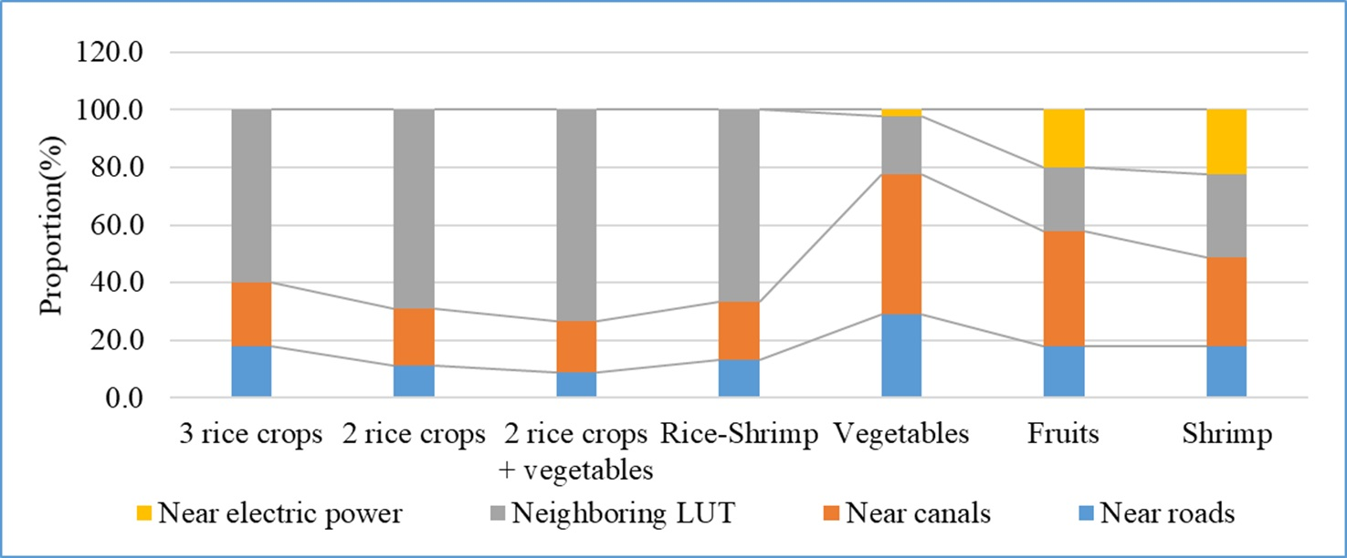

Figure 4. Infrastructure requirements of LUTS

The three LUTs influenced by neighbor land uses are two rice crops, three rice crops, and rice-shrimp. If nearby homes raise shrimp or keep salt water in the pond, neighboring rice-growing households will be unable to cultivate or will obtain low yields. The most important priority for shrimp and fruit farming was a strong electric power source to operate machinery, followed by the need to be positioned near a road and the effect of neighboring LUTs. In reality, if they wish to cultivate aquaculture items, the nearby homes must also cultivate in the same manner, resulting in great efficiency. Approximately 20% of respondents agreed that vegetables and fruits should be grown near rivers and canals. However, due to farmer agricultural practices, vegetables and fruit have to be positioned near the road.

3.2. Application of integrated systems in Soc Trang province

3.2.1 Land evaluation

Land mapping unit (LMU) maps were created by utilizing the Union technique to analyze maps such as soil, depth to the acid sulfate soil (ASS) happened, water salinity, and water salinity duration maps of three districts in Soc Trang province (Long Phu, Tran De, and My Xuyen). The districts' LMU map was divided into 28 LMUs as in Figure 5.

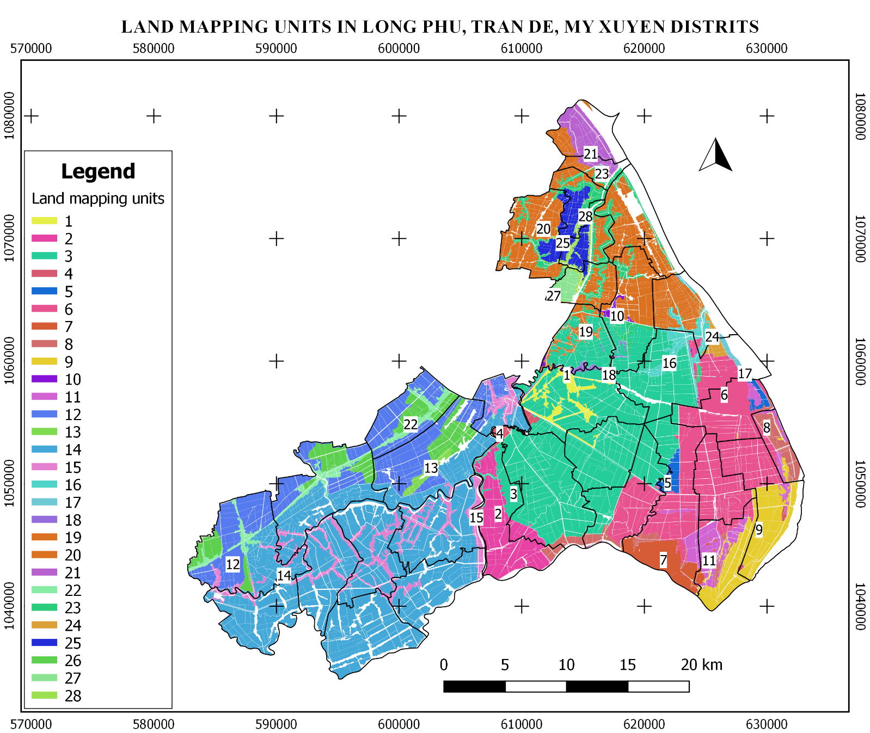

Figure 5. Land mapping units of the study area.

Table 5 shows the detailed attributes of the units. Unit 14 has the largest land area (18,586.90 ha) in My Xuyen district, with soil characteristics of Fluvisols soil type, depth acid sulfate soil layer showing less than 50cm, salinity 8 (), and salinity period of 6 months each year. There are two large-scale land units in Tran De district: unit 3 and unit 6, which have areas of 16,996.50ha and 10,047.49ha, respectively. These are low salinity land units since they are located in the dyke and are supplied with fresh water via the canal system, but irrigation capacity can only cover the needs of two crops.

Table 5. Land suitability of land mapping units

|  |  |  |  |  |  |  |  |  |  |  |  |  |
| --- | --- | --- | --- | --- | --- | --- | --- | --- | --- | --- | --- | --- |
| LMU | Soil type | Acid sulphate  occurred | Salinity (‰) | Persistence of Salinity (months) | Irrigation capability (months) | LUT1 | LUT2 | LUT3 | LUT4 | LUT5 | LUT6 | LUT7 |
| 1 | Anthrosols | No | 2-4 | 5 | 7 | 0.00 | 0.00 | 0.00 | 0.00 | 0.33 | 1.00 | 0.00 |
| 2 | Fluvisols | Active at <50cm | 2-4 | 6 | 6 | 0.00 | 0.67 | 0.67 | 0.00 | 0.33 | 0.00 | 0.00 |
| 3 | Fluvisols | Active at >50cm | 2-4 | 5 | 7 | 0.00 | 0.67 | 0.67 | 0.00 | 0.67 | 0.00 | 0.00 |
| 4 | Anthrosols | No | 4-6 | 5 | 7 | 0.00 | 0.00 | 0.00 | 0.67 | 0.00 | 0.00 | 0.33 |
| 5 | Arenosols | No | 4-6 | 6 | 6 | 0.00 | 0.33 | 0.33 | 0.00 | 0.67 | 0.67 | 0.00 |
| 6 | Fluvisols | Active at <50cm | 4-6 | 5 | 7 | 0.00 | 1.00 | 0.67 | 0.00 | 0.67 | 0.33 | 0.00 |
| 7 | Anthrosols | Active at >50cm | 12-20 | 12 | 0 | 0.00 | 0.00 | 0.00 | 0.33 | 0.00 | 0.00 | 0.67 |
| 8 | Fluvisols | No | 12-20 | 12 | 0 | 0.00 | 0.00 | 0.00 | 0.33 | 0.00 | 0.00 | 0.67 |
| 9 | Fluvisols | Active at <50cm | 12-20 | 12 | 0 | 0.00 | 0.00 | 0.00 | 0.67 | 0.00 | 0.00 | 1.00 |
| 10 | Fluvisols | Active at <50cm | 2-4 | 3 | 9 | 0.00 | 0.67 | 0.33 | 0.00 | 0.33 | 0.67 | 0.00 |
| 11 | Anthrosols | Active at >50cm | 4-6 | 5 | 7 | 0.00 | 0.67 | 0.33 | 0.00 | 0.67 | 0.00 | 0.00 |
| 12 | Fluvisols | No | 6-8 | 3 | 9 | 0.00 | 1.00 | 0.67 | 0.00 | 0.67 | 0.33 | 0.00 |
| 13 | Arenosols | No | 2-4 | 3 | 9 | 0.00 | 0.33 | 0.00 | 0.00 | 1.00 | 0.67 | 0.00 |
| 14 | Fluvisols | Potential at <50cm | 8-12 | 6 | 6 | 0.00 | 0.00 | 0.00 | 1.00 | 0.33 | 0.00 | 0.33 |
| 15 | Anthrosols | Potential at >50cm | 6-8 | 6 | 6 | 0.00 | 0.00 | 0.00 | 0.00 | 0.67 | 1.00 | 0.00 |
| 16 | Anthrosols | Potential at >50cm | 2-4 | 3 | 9 | 0.00 | 0.33 | 0.33 | 0.00 | 0.67 | 1.00 | 0.00 |
| 17 | Fluvisols | Active at <50cm | 8-10 | 6 | 6 | 0.00 | 0.00 | 0.00 | 0.00 | 0.67 | 0.33 | 0.67 |
| 18 | Anthrosols | Potential at >50cm | <2 | 5 | 7 | 0.00 | 0.00 | 0.00 | 0.00 | 1.00 | 0.33 | 0.00 |
| 19 | Anthrosols | Potential at >50cm | <2 | 3 | 9 | 0.00 | 0.00 | 0.00 | 0.00 | 1.00 | 0.33 | 0.00 |
| 20 | Fluvisols | No | 2-4 | 3 | 9 | 1.00 | 0.67 | 0.67 | 0.00 | 0.67 | 1.00 | 0.00 |
| 21 | Fluvisols | No | 2-4 | 6 | 6 | 0.33 | 0.67 | 0.67 | 0.00 | 0.67 | 1.00 | 0.00 |
| 22 | Anthrosols | Potential at >50cm | 2-4 | 5 | 7 | 0.00 | 0.00 | 0.00 | 0.00 | 0.67 | 1.00 | 0.00 |
| 23 | Anthrosols | No | 2-4 | 2 | 10 | 0.00 | 0.00 | 0.00 | 0.00 | 0.67 | 1.00 | 0.00 |
| 24 | Arenosols | No | 8-10 | 5 | 7 | 0.00 | 0.00 | 0.00 | 0.00 | 0.67 | 0.67 | 0.33 |
| 25 | Fluvisols | Active at >50cm | 2-4 | 6 | 6 | 0.67 | 0.67 | 1.00 | 0.00 | 0.67 | 0.00 | 0.00 |
| 26 | Fluvisols | Potential at <50cm | 6-8 | 6 | 6 | 0.00 | 0.67 | 0.67 | 0.00 | 0.33 | 0.33 | 0.00 |
| 27 | Fluvisols | No | 6-8 | 3 | 9 | 0.67 | 0.67 | 0.67 | 0.00 | 0.67 | 0.67 | 0.00 |
| 28 | Anthrosols | Active at >50cm | 2-4 | 3 | 9 | 0.00 | 0.00 | 0.00 | 0.00 | 0.67 | 1.00 | 0.00 |

Notes: 1.00: Highly suitable, 0.67: Moderately suitable, 0.33: Marginally suitable, 0.00: Non-suitable.

In addition, the results of the adaptive classification for 7 land use types across 28 land units are also shown in Table 5. FAO (1976) adaptation levels are classified according to the levels of S1, S2, S3 and N which correspond to highly suitable, moderately suitable, marginally suitable, and non- suitable. These values are normalized to 1, 0.67, 0.33 and 0.

3.2.2. Configuring optimization scenarios

The optimization scenarios were set to optimize the agricultural land area of the three districts until 2030 with socio-economic and environmental changes.

Scenario 1: Optimizing agricultural land until 2030 under normal conditions. This scenario was designed to determine the optimal land area and land allocation for agricultural production under actual natural conditions and socio-economic development until 2030.

Scenario 2: Optimizing agricultural land to 2030 under conditions of environmental and natural changes similar to the drought and salinity intrusion phenomenon in 2016. It was recommended by authorities that farmers reduce three rice crop areas. Thus, this scenario is to explain when the three-rice-crop area is recommended not to be used as before, which LUT needs to be used to replace it.

For each scenario, there were 3 alternatives: Optimizing land suitability level, optimizing profits, and optimizing multiple objectives (profits, labor, risks, and environmental benefit). Regarding the limited areas of the LUTs in the scenarios, the minimum and maximum thresholds of the LUT’s area were defined in Table 6. In the optimization model, the unlimited represented by a constant number (1,000,000 ha). It is a number greater than the study area.

Table 6. Restricted area for the LUTs in the two scenarios

| LUT | Scenario 1 | | Scenario 2 | | | |
| --- | --- | --- | --- | --- | --- | --- |
| Lower bound (ha) | Upper bound (ha) | | Lower bound (ha) | Upper bound (ha) |
| LUT1 | 0 | Unlimited | | 0 | Unlimitted |
| LUT2 | 0 | Unlimited | | 0 | Unlimitted |
| LUT3 | 0 | 12,768.00 | | 0 | 15,436.00 |
| LUT4 | 0 | Unlimitted | | 0 | Unlimitted |
| LUT5 | 0 | 2,100.01 | | 0 | 2,500.01 |
| LUT6 | 0 | 8,799.00 | | 0 | 8,936.00 |
| LUT7 | 0 | 16,697.01 | | 0 | 19,236.01 |

3.2.3. Exploring weights of the Land optimization module

The weight of the objectives is set by default in the two scenarios to 1, which indicates that the weights are equal. The Land Optimization module provides functionality that allows users to automatically search for target weights based on historical land use, with each set of target weights showing the total area for each land use type to compare with the statistical area. From there, determine the appropriate set of weights for the local objectives.

The objective parameters of the optimization were explored by combining 3 target parameters (W1, W2, and W3). In which profit parameter (W1) that can receive from 0.1 to 0.8; W2 from 0.1 to 0.9; W1 and W3 are the compensation for the two first parameters. The explored result of 36 sets of parameters showed that the weights W1 = 0.4, W2 = 0.2, and W3 = 0.4 were selected to develop multi-objective agricultural land-use optimization for two scenarios.

3.2.4. Optimizing agricultural land-use area

The ISALUP model is applied to 3 districts of Long Phu, Tran De, and My Xuyen of Soc Trang province, Vietnam through 2 scenarios described in section 3.2.3.

Figure 6 depicts the results of the optimization of the area of LUTs under Scenario 1, in which the land use distribution maps of the three options were analyzed, including adaptation level optimization (Figure 6a), optimal Profit maximization (Figure 6b), and optimization of the combined socio-economic and environmental goals (Figure 6c). In such case, the map of option 1 (Figure 6a) differs significantly from the other two options (Figures 6b and 6c), which are mostly represented by the amount of rice-crop land and shrimp farming land. The distribution of crop rice in Option 1 is concentrated in the northern part of Long Phu district while for the other 2 options, the area for crop rice is arranged further along the road in Tran De district. For shrimp farming land, the maps of options 2 and 3 both show the same arrangement in My Xuyen districts (western part of the maps).

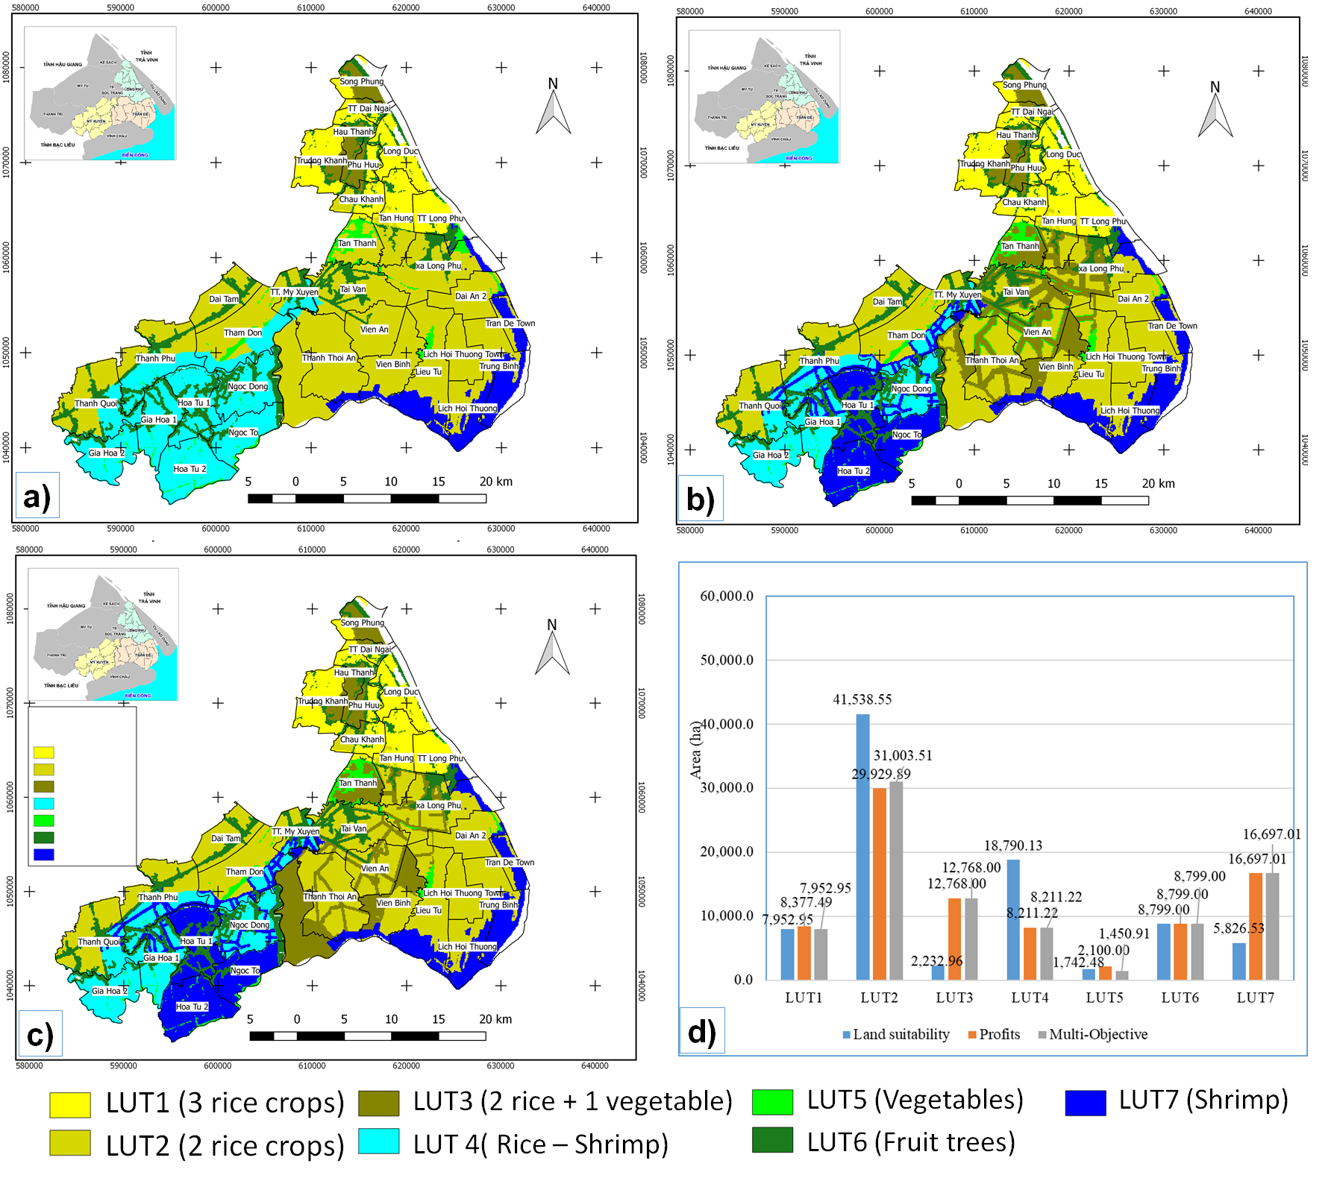

a) Option 1: Maximization of land suitability b) Option 2: Maximization of profits

c) Option 3: Maximization multiple objectives d) Land-use area of 3 alternative options.

Figure 6. Land-use maps of tree alternatives in Scenarios 1

A more extensive analysis of the area of scenario 1 (Figure 6d) reveals that three rice crops (LUT1) and fruit trees (LUT6) have comparable distribution areas due to area requirements in the three alternatives. However, the area of the two rice crops (LUT2) and rice-shrimp crops (LUT4) in the option 1 is more than that of the other two options, totaling more than 10,000 hectares for each kind due to the high land suitability but poor lucrative use patterns. In contrast, the amount of rice-crop land (LUT3) is less than 10,000 ha smaller than the other two alternatives due to limited adaptability but high profit. The remaining land use types of the two alternatives have similar areas, although the size of LUT2 and LUT5 of option 1 is 400ha and 550ha larger, respectively, than that of option 2. Option 1's LUT2 analysis is superior to that of Option 2. The results reveal that option 3 has several advantages in terms of the environment and risk limits of option 1, as well as the profit advantages of option 2.

For scenario 2, under the conditions of environmental change due to climate change, the results of analysis of 3 land-use options in 2030 are shown in Figure 7. Regarding the maps of the 3 alternatives, the map in Figure 7a gives similar results to Figure 6a and has a difference compared to the other 2 options (Figure 7b and Figure 7c). The remaining two optimization options show that the layout of shrimp land is similar to each other. However, the area and arrangement of rice-crop land (LUT3) are different. Option 2 focuses on arranging rice-vegetable crops in Tran De district while Option 3 focuses on arranging this type in Long Phu district. The reason for the different spatial arrangement of LUT 3 while having the same required area is because the land units arranged for 2-rice crop land of option 3 are higher while the area for growing vegetables is less than the one in Option 2.

Areas of land use types of the 3 alternatives of scenario 2 are shown in Figure 7d. In which, 3-crop rice is no longer arranged in all 3 options. The two-crop rice area of option 1 is significantly higher than that of the other two options because this difference is allocated to rice-vegetable cultivation. Similarly, the rice-shrimp area of 2 options 2 and 3 of scenario 2 is much lower than that of option 1 due to the conversion from rice-shrimp land to shrimp farming land.

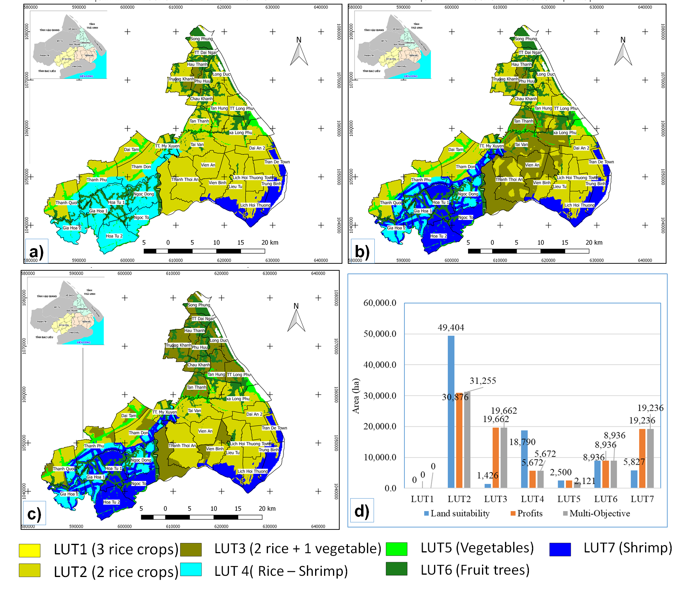

a) Option 1: Maximization of land suitability b) Option 2: Maximization of profits c) Option 3: Maximization multiple objectives d) Land-use area of 3 alternative options.

Figure 7. Land-use maps of 3 alternatives in scenarios 2.

3.2.5. Examining for the best options

With 6 examined possibilities of two situations, the total profit of the solutions is a significant component in determining which alternative option to select. However, environmental goals and risk minimization should be taken into account while selecting solutions. Figure 8 depicts the total return of the six alternative options. In both scenarios, the profit maximization plan provides the maximum profit, followed by the multi-objective optimal solution, while the adaptive maximization plan yields the lowest profit. In the absence of the effects of climate change.

When the overall profit of the two extremely profitable alternatives is considered, the difference is not significant, amounting to 24.4 billion VND for option 2 and 74.4 billion VND for option 3. When we consider the environmental component, option 3 in each scenarios produces the best results because it meets the overall goal. As a result, based on the circumstances, option 3 is offered to maximize the synthesis as a foundation for determining the planning possibilities.

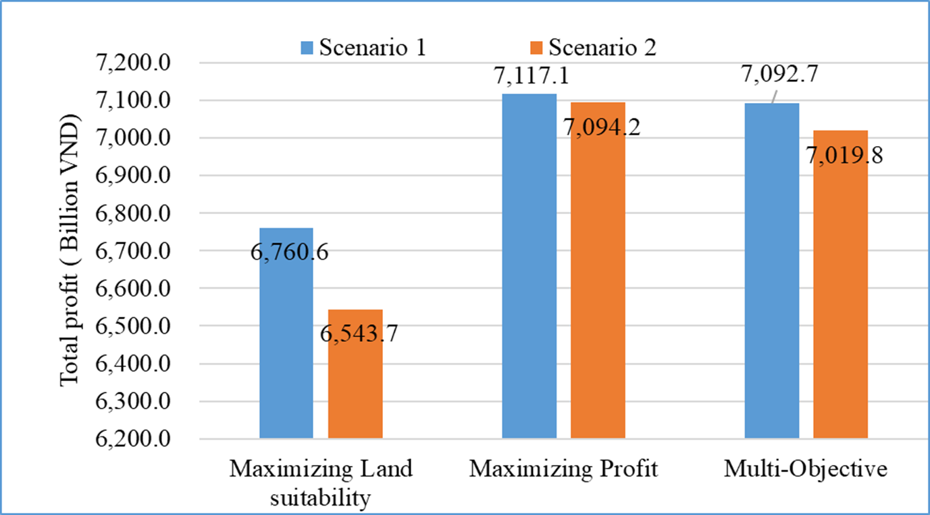

Figure 8. Compare the total profit of the two scenarios in 2030

The model also includes an overlay feature that allows users to define the areas to be converted for the proposed alternative based on the allotted map. Figure 9 depicts the allocation map of the multi-objective alternative of Scenario 1 compared to the 2015 land use map (Figure 9b), and the conversion map. Figure 9c depicts the darkened regions that should be altered if the strategy is adopted.

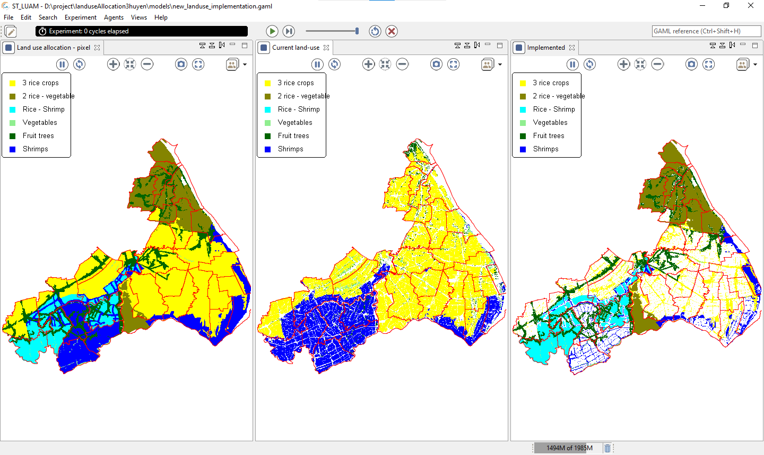

Optimized map (b) Land-use map in 2015 (c) Areas to be converted

Figure 9. Different maps in 2015 of scenario 1 between the multi-objective map and the land-use map.

4. Discussion

This study has established a predesigned tool for optimization and land allocation in the Mekong Delta using proven criteria from prior studies [26,27,29], as well as environmental and risk assessment criteria of usage patterns. Furthermore, the priority policy deploy ability component is incorporated into the land layout model. The results also demonstrate that the integrated model makes it easier for planners to utilize due to the model's predefined impact variables. The optimization findings are then distributed spatially based on socioeconomic characteristics and local infrastructure.

Previous research found that the execution of planning options frequently encountered capital issues [36] since the land allocation model did not integrate this component in the geographic distribution. When examining the economic criterion (investment ability) of farming kinds with high capital requirements, ISALUP's land allocation model took this limitation into account. Although the commune's priority arrangement in terms of space is still limited due to the lack of a criterion for selecting the investment potential value for each pixel, the commune targeted for development in the district's policy will be prioritized for distribution. more places on the same land unit.

In this study, the value utilized helps to quantify the effect levels of the elements in the land allocated that other studies have demonstrated [9] for the risk factors of the land-uses and the environmental benefits of the uses.

The optimization strategies presented in this article are examined, with three alternatives for each scenario, including two scenarios corresponding to normal conditions and under situations of environmental change. In general, multi objective optimization is important for environmental protection because it has the lowest risk but also the lowest reward. Harmonization of the profitability, risk reduction, and negative environmental impact of intensive shrimp farming [9] by the utilization of rice-shrimp and rice - vegetables [5,6]. The area for rice shrimp has been guaranteed, and the area for rice crops has been enlarged, allowing people to lower the quantity of rice crops while still ensuring income. This promises to make the plan easy to deploy and propagate among farmers.

To take use of the advantages of each platform, the two modules of the integration model are often deployed on two different platforms: The optimized module is created using the Windows application program interface (Visual Studio). The land allocation module is built on the GAMA platform [35], which is ideal for creating spatial layout models using multi-criteria analysis. The optimization module includes various choices for creating constraints equations that may be added and removed freely, but the program has not been built to incorporate additional elements. In terms of spatial layout, the spatial layout model is used when land units are grouped into one to three land use kinds. When numerous land use types have the same priority, the system demands the creation of a priority list organized by the infrastructure element for the land use types.

Because users must operate two different modules, this two-module integrated solution remains challenging to use. This limitation can be overcome through extensive research and development of a comprehensive coupling model with the headless mode of the optimized module to make users more technically transparent to make it easier for non-technical managers.

In addition, forecasting of agricultural production is essential for land use planning, which has not been implemented in this study. Therefore, it is necessary to expand agricultural production forecasting research to serve as input for the constraints of optimizing land use area.

Despite some restrictions, the built-in integrated system enables users to build solutions for agricultural land use planning, assisting in the development of scientifically sound plans under Mekong Delta conditions in Vietnam.

5. Conclusions

ISALUP, an integrated land use planning system (ISALUP) influenced by socioeconomic considerations, has been established. The system is made up of two major components: (1) The Land Optimization Module optimizes agricultural land utilization; (2) The Land Allocation Subsystem arranges agricultural land. This method optimizes land use and calculates the optimal area for land use systems with single-objective optimization functions (such as profitability, land suitability) and maximum optimization. objectives (profit, labor, risk reduction and environmental advantages).

The integration model helps to solve the problem of arranging different LUTs in a land unit thanks to the newly proposed land allocation module. In which, competitive LUTs are prioritized according to the criteria of proximity, proximity to roads, proximity to canals and the investment ability of the commune. Based on the function of the software, the manager can survey many options to serve as a basis for choosing a planning option.

The results of the system in three districts of Soc Trang province (Long Phu, My Xuyen, and Tran De) show that the multi-objective optimal solution in the two scenarios is chosen thank to the balance between profitability and risk minimization, as well as negative environmental impacts.

ISALUP should be used in a variety of irrigation settings as well as with a variety of land-use schemes to further adjust to the actual conditions.

References